ARTIST-IN RESIDENCE PROGRAM
MAHANAIM BARICHARA
ARTiculating rurality
Barichara, Colombia (South America)

AN INITIATIVE FROMFUNDACION MAHANAIM CENTRO RURAL
Non for profit organization whose mission is to promote spaces, experiences and routes of art from and towards the rural.

The residency program is aimed at artists, creators, explorers, who want to spend some time away from home and their routine to focus on inspiration, research and artistic production. The residence is set in a period between 2 and 6 weeks ideally. The residency takes place in Mahanaim Rural and Art Center (Mahnaim CRA), in Barichara, the most beautiful little town in Colombia.

MAHANAIM AIR have two main characteristics:

1. It is developed within the platform of RURAL & ART CIRCUIT, connecting the resident with the rich local arts community. The artist is invited to experience the rural living and its implications, within an inspiring and beautiful natural environment, and at the same time to approach the various local techniques, initiatives and proposal within the plastic arts in subjects such as painting, ceramics, sculpture, carving in stone or wood, land and mix techniques on canvas, artistic fabric, etc.

2. In line with our mission, we prioritize artistic proposals that take into account issues related to rural areas, for which the resident has access to local experiences that provide appropriate information to strengthen their proposal. The following topics are suggested:
• Life in the contryside (use of natural resources, traditions, legends, challenges and needs)
• The work of the land (agricultural practices, food industry, impact and challenges)
• The man in the landscape (interventions, alterations, fauna and flora of the region)
• Rural Exodus, Rural re-integration, new-ruralism
The participant may, however, focus on any subject or project of his / her choice.

OUR FACILITIES
THE HOUSE
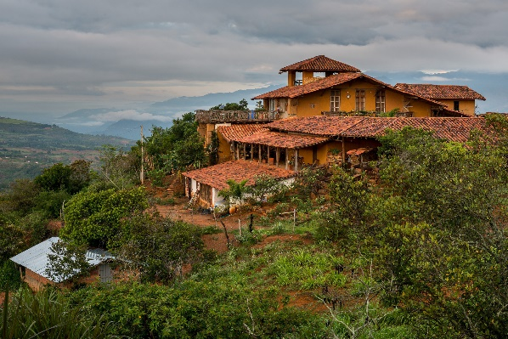 | 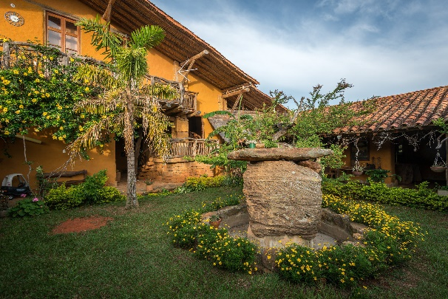

We have capacity to host up to 8 artists at a time, nonetheless the artist-in residency can be taken in smaller groups or individually at any time during the year.

ACCOMODATION
- Four single/double rooms with private bathroom
- One shared room (up to 4 people) with private bathroom
- One shared room (up to 6 people) with private bathroom

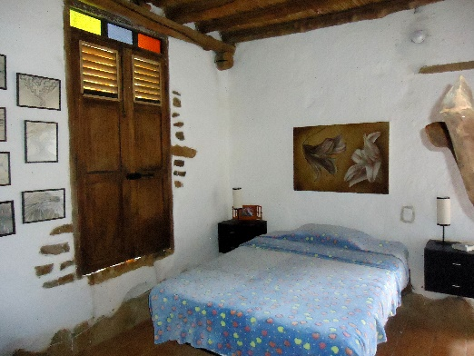 | 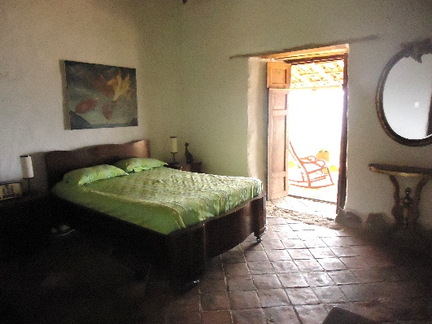

ART STUDIOS
Within the House
Our studios are adapted to activities such as painting, drawing, clay modeling and writing.
- We offer 2 interior studios to be shared by two artists during full occupancy.
- We offer 2 open studios outside the house which can be shared by all artist. They are surrounded by nature and beautiful views.

Art Studios available in the town
- We have alliances with local artist to provide training in subjects such as ceramic modeling, bronze sculpture, stone and wood carving, artistic fabric, among others, This may represent extra costs.

LOCATION
Mahanaim CRA is located in Barichara (Santander), considered the prettiest village in Colombia, at a 1600 meters above sea level, its annual average temperature reaches 21 degrees centigrade. Barichara is recognized for his constructions of the late eighteenth century, it has been declared as a cultural heritage in the country. The municipality has numerous restaurants, hotels, cafes and bars that keep the colonial architecture. It has also been the spot of various movies and film theater and other festivals. Barichara means inGuane Indian language "resting place ".

COSTS
The MAHANAIM2-WEEK AIR program has a basic fee of:
- Individual residency: USD 610, any time of the year.
- Collective residency (3 to 8 people): USD 350 per person, who are willing to share room, art studios, transport,
The basic fee covers:
• Transport from Barichara to Mahanaim CRA at the beginning and end of the residency program
• Accommodation B&B in single or shared room with private bathroom
• Access to art studios (in situ: painting, clay modelling, wood or stone carving)
• Insertion to the RURAL & ART CIRCUITplatform (connection and training with local artists)
• Daily Transport to the town, departure: 7 am - return: 3 pm
• Participation in the annual Art Exhibition "MAHANAIM Art & Rural"
• WiFi
• Special discounts to MAHANAIM AIR program in Manabí (Ecuador), through partner organizations.

Each extra week has a cost of:
- Individual residency: USD 190
- Collective residency: USD 130

Services available for an extra cost:
- Lunch: USD 5
- Dinner: USD 3
- Laundry: USD 5
- Transport to town out of pre-defined daily schedule: USD 3per way
- Training with local artists: according to selected artist’s fees
- Touristic plans: according to plan chose
- Participation in cultural activities, exhibitions, festivals, seminars, etc., that are part of the cultural agenda of the municipality (according to dates of residency)

The program does not cover:
- Transportation from the place of origin to Barichara and return
- Cost of visa procedures
- Health insurance
- Art materials needed, tools, personal work (except for easels)

EXPECTATIONS FROM THE ARTIST
- Stay of minimum 2 maximum of 6 weeks
- Book with 30% of the total fee
- Deliver an art training workshop to rural neighbors (at least 1 session)
- Conduct a closing residency activity (conference, workshop, documentary, exhibition, etc.) regarding its experience in Barichara and within the community.
- Optional: Participation in the annual exhibition hold in Octobre each year with a piece of the artwork developed during residency (transportation costs to return by the artist).
- 15% of sales made during residency will be allocated to support our programs.
- Have a health insurance with coverage for the whole period of stay.

FINANCING
Scholarships and Sponsorships
There are local and international cultural organizations that offer scholarships, sponsorship and support for this kind of artistic activity.
For Colombian nationals MAHANAIM CRA has established an alliance with the MINISTRY OF CULTURE of Colombia. Applications are carried out during February- April each year.
http://www.mincultura.gov.co/planes-y-programas/programas/programa-nacional-estimulos/nuestros-aliados/Paginas/Aliados/Mahana%C3%ADm.aspx
For overseas national, at the moment you will have letters of acceptance to the program, which you may present in your country for funding.
Self -financing
Artists who are members of RURAL & ART CIRCUIT and who have to self-finance the AIR program, will obtain a discount of 10% on the costs included in the program. We encourage artist to participate collectively to lower costs. They can participate as groups or collective of artists who wish to present an artistic rural joint proposal. In this case, they will share room, art studios, transport facilities, training workshops and other offered services and the costs thereof.

FORM OF PAYMENT
- Bank Deposit:
BANK: BANCOLOMBIA
NAME: FUNDACION MAHANAIM CENTRO RURAL
IDENTIFICATION NIT: 900.958.125
SAVINGS ACCOUNT NO. 322 581587 -41
SWIFT CODE: COLOCOBM (fill in with XXX in case of additional space)

- Money Transfer
Western Union, Money Gram, etc., RECIPIENT: Lina Rebeca Rueda Rodríguez, IDENTITY CARD (CC) 37.558.124 from Bucaramanga, CELLULAR:+57 316 2218177. NEAREST OFFICE: San Gil, Santander, Colombia.

CONTACT DETAILS
Address: Vereda Los Cauchos, vía antigua Villanueva Barichara km. 1,5. Turn left and go up the hill one more km.
Cellular number: +57 3162218177 +57 313 3542423, or 593 939872331
FB: Fundacion Mahanaim and CIRCUITO ARTISTICO RURAL
Mail: mahanaim.centrorural@gmail.com

How to get to Mahanaim CRA
From place of origin there are two ways to get to Barichara:

- Arriving to Bucaramanga (LAN, Avianca, Copa) and Bucaramanga – Barichara (by bus CootraSangil – 2,5 hour drive). Bus ticket $20.000 (USD 7 aprox.)

- Arriving to Bogotá (Avianca, Iberia, KLM, etc) and Bogotá – San Gil (by bus Berlinas del Fonce - 6 hour drive). Bus ticket $60.000 (USD 15 aprox.) / San Gil - Barichara (by bus Cootrasangil - 20 minute drive. Bus ticket $5000 (USD 2 aprox.)

From Barichara to Mahanaim CRA (Centro Rural & Arte)

Upon arrival to Barichara we will pick the resident up in the town in a private vehicle and have him/her settled in Mahanaim CRA which is located at 3 km from the town.
Other means of transport available: moto-taxi.

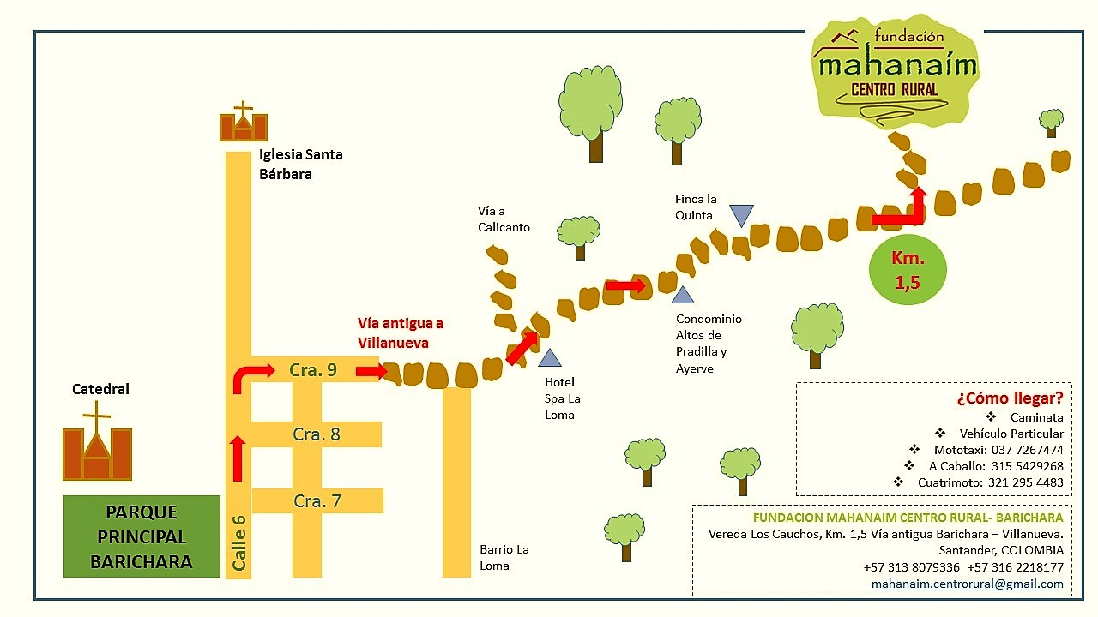

VISAS
Check the website of the Ministry of Foreign Affairs for your visa procedure at:
http://www.cancilleria.gov.co/tramites_servicios/visas

HOW TO APPLY
MAHANAIM AIR might be carried out at any time during the year, according to artist’s availability.
Nonetheless, in order to participate in our annual exhibition we recommend to hold it from September – October (1st to 15th).

Application must be submitted at least two months in advance to the expected beginning date.

To apply please
- Send to mahanaim.centrorural@gmail.com, with the subject: "Application MAHANAIM Residency " the following information:
  - Completed application form attached below or downloaded from http://mahanaim-cra.weebly.com/residencia-en-colombia.html
  - CV
  - 4 Photographs of your most representative artworks

- Make a payment of 30% of total fee at least one month prior to beginning of residency

APPLICATION FORM
GENERAL INFORMATION
NAME
Date / place of birth
Address
Phone number |  | e-mail
Facebook |  | Skype

PROFESSIONAL INFORMATION
Your profession

Artistic discipline of expertise

Artistic organizations you belong to
Professional reference(name, mail)

YOUR RESIDENY PROGRAM
Do you have a proposal or specific activity to work on during your residency?Describe briefly objectives, activities, etc.
What kind of materials, spaces or information would you need for your residency work?
Will your proposal raise somehow awareness about challenges in the rural sector?
What kind or personal or professional contribution do you expect from the residency?

ABOUT YOUR STAY
Date(beginning - end)
Modality (individual, collective)
Specific requirements(meals, mobility, etc.)
How would you finance your residency?
Where did you hear about us?
In case of emergency we can contact: (name, cel, mail, Skype)

¡THANK YOU!

